Genrong Zhong



Rockbuster Stealth LLC Data Dictionary

Table of Contents

Entity Relationship Diagram 0

Fact Tables 0

Payment Table 0

Links to 0

Rental Table 0

Links from 0

Links to 0

Dimension Tables 1

Store Table 1

Links to 1

Film Actor Table 1

Links to 1

Inventory Table 1

Links from 2

Links to 2

Film Category Table 2

Links to 2

Customer Table 2

Links from 3

Links to 3

Staff Table 3

Links from 3

Links to 3

Actor Table 3

Links from 4

Table 4

Join 4

film_actor 4

film_actor.actor_id = actor.actor_id 4

Category Table 4

Links from 4

Film Table 4

Links from 4

Links to 5

Address Table 5

Links from 5

Links to 5

City Table 5

Links to 6

Country Table 6

Links from 6

# Entity Relationship Diagram

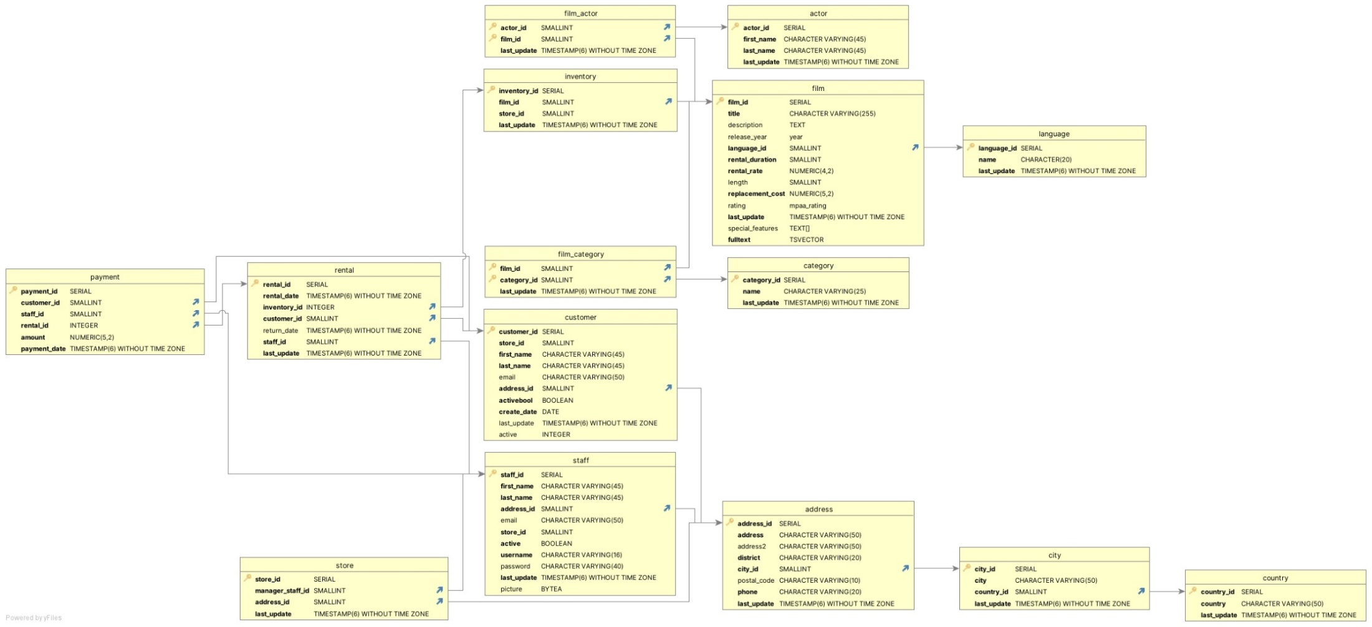

# Fact Tables

## Payment Table

|  |  |  |  |
| --- | --- | --- | --- |
| Key Type | Columns | Data Type | Description |
| Primary | payment_id | SERIAL | A unique id to identify the payment. |
| Foreign | customer_id | SMALLINT | A unique id to identify the customer. |
| Foreign | staff_id | SMALLINT | A unique id to identify the staff. |
| Foreign | rental_id | INTEGER | A unique id to identify the rental. |
|  | amount | NUMERIC(5,2) | The total amount that the customer paid. |
|  | payment_date | TIMESTAMP(6) WITHOUT TIME ZONE | The date that the payment was made. |

## Links to

|  |  |
| --- | --- |
| Table | Join |
| customer | payment.customer_id = customer.customer_id |
| rental | payment.rental_id = rental.rental_id |
| staff | payment.staff_id = staff.staff_id |

## Rental Table

|  |  |  |  |
| --- | --- | --- | --- |
| Key Type | Columns | Data Type | Description |
| Primary | rental_id | SERIAL | A unique ID that identifies the rental. |
|  | rental_date | TIMESTAMP(6) WITHOUT TIME ZONE | The date when the rental was purchased. |
| Foreign | inventory_id | INTEGER | A unique ID that identifies the item in inventory. |
| Foreign | customer_id | SMALLINT | A unique ID that identifies the customer. |
|  | return_date | TIMESTAMP(6) WIHTOUT TIME ZONE | The date when the rental was returned. |
| Foreign | staff_id | SMALLINT | A unique number that identifies the employee. |
|  | last_update | TIMESTAMP(6) WITHOUT TIME ZONE | The date and time when the row was last updated. |

## Links from

|  |  |
| --- | --- |
| Table | Join |
| payment | payment.rental_id = rental.rental_id |

## Links to

|  |  |
| --- | --- |
| Table | Join |
| inventory | rental.inventory_id = inventory.inventory_id |
| customer | rental.customer_id = customer.custoimer_id |
| staff | rental.staff_id = staff.staff_id |

# Dimension Tables

## Store Table

|  |  |  |  |
| --- | --- | --- | --- |
| Key Type | Column | Data Type | Description |
| Primary | store_id | SERIAL | A unique ID that identifies the store. |
| Foreign | manager_staff_id | SMALLINT | A unique ID that identifies the manager. |
| Foreign | address_id | SMALLINT | A unique ID that identifies the store address. |
|  | last_update | TIMESTAMP(6) WITHOUT TIME ZONE | The date and time when the row was last updated. |

## Links to

|  |  |
| --- | --- |
| Table | Join |
| staff | store.staff_id = staff.staff_id |
| address | store.address_id = address.address_id |

## Film Actor Table

|  |  |  |  |
| --- | --- | --- | --- |
| Key Type | Column | Data Type | Description |
| Composite (Primary and Foreign) | actor_id | SMALLINT | A unique ID that identifies the actor. |
| Composite (Primary and Foreign) | film_id | SMALLINT | A unique ID that identifies the film. |
|  | last_update | TIMESTAMP(6) WITHOUT TIME ZONE | The date and time when a row was last updated. |

## Links to

|  |  |
| --- | --- |
| Table | Join |
| actor | film_actor.actor_id = actor.actor_id |
| film | film_actor.film_id = film.film_id |

## Inventory Table

|  |  |  |  |
| --- | --- | --- | --- |
| Key Type | Column | Data Type | Description |
| Primary | inventory_id | SERIAL | A unique ID that identifies the item in inventory. |
| Foreign | film_id | SMALLINT | A unique ID that identifies the film. |
|  | store_id | SMALLINT | A unique ID that identifies the store. |
|  | last_update | TIMESTAMP(6) WITHOUT TIME ZONE | The date and time when the row was last updated. |

## Links from

|  |  |
| --- | --- |
| Table | Join |
| rental | rental.inventory_id = inventory.inventory_id |

## Links to

|  |  |
| --- | --- |
| Table | Join |
| film | inventory.film_id = film.film_id |

## Film Category Table

|  |  |  |  |
| --- | --- | --- | --- |
| Key Type | Column | Data Type | Description |
| Composite Key (Primary and Foreign) | film_id | SMALLINT | A unique ID that identifies the film. |
| Composite Key (Primary and Foreign) | category_id | SMALLINT | A unique ID that identifies the category. |
|  | last_update | TIMESTAMP(6) WITHOUT TIME ZONE | The date and time when the row was last updated. |

## Links to

|  |  |
| --- | --- |
| Table | Join |
| film | film_category.film_id = film.film_id |
| category | film_category.category_id = category.category_id |

## Customer Table

|  |  |  |  |
| --- | --- | --- | --- |
| Key Type | Column | Data Type | Description |
| Primary | customer_id | SERIAL | A unique ID that identifies the customer. |
|  | store_id | SMALLINT | A unique ID that identifies the store |
|  | first_name | CHARCTER VARYING(45) | The first name of the customer. |
|  | last_name | CHARCTER VARYING(45) | The last name of the customer. |
|  | email | CHARCTER VARYING(45) | Email information of the customer. |
| Foreign | address_id | SMALLINT | Address information of the customer. |
|  | activebool | BOOLEAN | Whether the customer is active or not. |
|  | create_date | DATE | The date when the account was created. |
|  | last_update | TIMESTAMP(6) WITHOUT TIME ZONE | Date and time when the row was last updated. |
|  | active | INTEGER | Whether the customer is active or not. |

## Links from

|  |  |
| --- | --- |
| Table | Join |
| rental | rental.customer_id = customer.customer_id |

## Links to

|  |  |
| --- | --- |
| Table | Join |
| address | customer.address_id = address.address_id |

## Staff Table

|  |  |  |  |
| --- | --- | --- | --- |
| Key Type | Column | Data Type | Description |
| Primary | staff_id | SERIAL | A unique ID of the employee. |
|  | first_name | CHARCTER VARYING(45) | The first name of the employee. |
|  | last_name | CHARCTER VARYING(45) | The last name of the employee. |
| Foreign | address_id | SMALLINT | The address information of the employee. |
|  | email | CHARCTER VARYING(50) | The email information of the employee. |
|  | store_id | SMALLINT | A unique ID of the store. |
|  | active | BOOLEAN | Whether the employee is active or not. |
|  | username | CHARCTER VARYING(16) | The username of the employee account. |
|  | password | CHARCTER VARYING(40) | The password of the employee account. |
|  | last_update | TIMESTAMP(6) WITHOUT TIME ZONE | The date and name the row was last updated. |

## Links from

|  |  |
| --- | --- |
| Table | Join |
| payment | payment.staff_id = staff.staff_id |

## Links to

|  |  |
| --- | --- |
| Table | Join |
| address | staff.address_id = address.address_id |

## Actor Table

|  |  |  |  |
| --- | --- | --- | --- |
| Key Type | Column | Data Type | Description |
| Primary | actor_id | SERIAL | A unique ID that identifies the actor. |
|  | first_name | CHARCTER VARYING(45) | First name of the actor. |
|  | last_name | CHARCTER VARYING(45) | Last name of the actor. |
|  | last_update | TIMESTAMP(6) WITHOUT TIME ZONE | The date and time the row was last updated. |

## Links from

|  |  |
| --- | --- |
| Table | Join |
| film_actor | film_actor.actor_id = actor.actor_id |

## Category Table

|  |  |  |  |
| --- | --- | --- | --- |
| Key Type | Column | Data Type | Description |
| Primary | category_id | SERIAL | A unique ID that identifies the category. |
|  | name | CHARCTER VARYING(25) | Name of the category. |
|  | last_update | TIMESTAMP(6) WITHOUT TIME ZONE | The date and time the row was last updated. |

## Links from

|  |  |
| --- | --- |
| Table | Join |
| film_category | film_category.category_id = category.category_id |

## Film Table

|  |  |  |  |
| --- | --- | --- | --- |
| Key Type | Column | Data Type | Description |
|  | film_id | SERIAL | A unique ID that identifies the film. |
|  | title | CHARCTER VARYING(255) |  |
|  | description | TEXT | It describes the story of the film. |
|  | release_year | year | The year the film released. |
|  | language_id | SMALLINT | The language of the film. |
|  | rental_duration | SMALLINT | How long the film was rented. |
|  | rental_rate | NUMERIC(4,2) | The date the film was rented. |
|  | length | SMALLINT | The length of the film. |
|  | replacement_cost | NUMERIC(5,2) | The cost to replace the film if it gets lost. |
|  | rating | mpaa_rating | The rating of the film. |
|  | last_update | TIMESTAMP(6) WITHOUT TIME ZONE | The date and time the row was last updated. |
|  | special_features | TEXT | The features that the film offers. |
|  | fulltext | TSVECTOR | Some keywords about the film. |

## Links from

|  |  |
| --- | --- |
| Table | Join |
| film_actor | film_actor.film_id = film.film_id |
| inventory | inventory.film_id = film.film_id |
| film_category | film_category.film_id = film.film_id |

## Links to

|  |  |
| --- | --- |
| Table | Join |
| language | film.language_id = language.language_id |

## Address Table

|  |  |  |  |
| --- | --- | --- | --- |
| Key Type | Column | Data Type | Description |
| Primary | address_id | SERIAL | A unique ID that identifies the address of the customer. |
|  | address | CHARCTER VARYING(50) | The address of the customer. |
|  | address2 | CHARCTER VARYING(50) | Second address of the customer if it applies. |
|  | district | CHARCTER VARYING(20) | The district that the customer lives in. |
| Foreign | city_id | SMALLINT | The city that the customer lives in. |
|  | postal_code | CHARCTER VARYING(10) | The postal code of the customer’s address. |
|  | phone | CHARCTER VARYING(20) | The customer’s phone number. |
|  | last_update | TIMESTAMP(6) WITHOUT TIME ZONE | The date and time the row last updated. |

## Links from

|  |  |
| --- | --- |
| Table | Join |
| customer | customer.address_id = address.address_id |
| staff | staff.address_id = address.address_id |
| store | store.address_id = address.address_id |

## Links to

|  |  |
| --- | --- |
| Table | Join |
| city | address.city_id = city.city_id |

## City Table

|  |  |  |  |
| --- | --- | --- | --- |
| Key Type | Column | Data Type | Description |
| Primary | city_id | SERIAL | A unique ID that identifies the city the customer lives in. |
|  | city | CHARCTER VARYING(50) | The city the customer lives in. |
| Foreign | country_id | SMALLINT | A unique ID that identifies the country where the customer lives in. |
|  | last_update | TIMESTAMP(6) WITHOUT TIME ZONE | The date and time the row last updated. |

## Links to

|  |  |
| --- | --- |
| Table | Join |
| country | city.country_id = country.country_id |

## Country Table

|  |  |  |  |
| --- | --- | --- | --- |
| Key Type | Column | Data Type | Description |
| Primary | country_id | SMALLINT | A unique ID that identifies the country where the customer lives in. |
|  | country | CHARCTER VARYING(50) | The country the customer lives in. |
|  | last_update | TIMESTAMP(6) WITHOUT TIME ZONE | The date and time the row last updated. |

## Links from

|  |  |
| --- | --- |
| Table | Join |
| city | city.country_id = country.country_id |